### **Experiment 2 : Visualization of data**

### **1. Correlation Heatmap**

A heatmap is used to visualize the correlation between numerical features in the dataset. It helps in identifying relationships between different variables.

#### **Code:**

****import seaborn as sns

import matplotlib.pyplot as plt

df_numeric = df.select_dtypes(include=[np.number]) # Select only numeric columns

plt.figure(figsize=(10, 6))

sns.heatmap(df_numeric.corr(), annot=True, cmap='coolwarm', linewidths=0.5)

plt.title('Correlation Heatmap of Stock Data')

plt.show()

#### **Explanation:**

* The function df.corr() calculates the correlation matrix.
* sns.heatmap() is used to create the heatmap.
* The annot=True argument ensures that correlation values are displayed.
* The colormap coolwarm visually distinguishes positive and negative correlations.
* 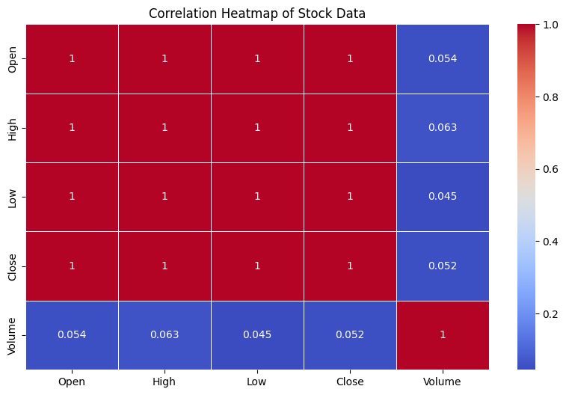

### **2. Stock Price Trend Graph**

A line plot is used to visualize the stock price trend over time. This helps in understanding how stock prices fluctuate.

#### **Code:**

****import matplotlib.dates as mdates

plt.figure(figsize=(12, 6))

plt.plot(df['Date'], df['Close'], color='blue')

plt.title('Stock Price Trend Over Time')

plt.xlabel('Date')

plt.ylabel('Closing Price ($)')

plt.xticks(rotation=45) # Rotate x-axis labels

plt.gca().xaxis.set_major_locator(mdates.AutoDateLocator()) # Auto adjust date intervals

plt.grid(True)

plt.show()

#### **Explanation:**

* plt.plot() is used to create a line graph of closing prices over time.
* plt.xticks(rotation=45) improves readability by rotating the dates.
* mdates.AutoDateLocator() automatically adjusts date intervals for better display.
* Grid lines are added for clarity.
* 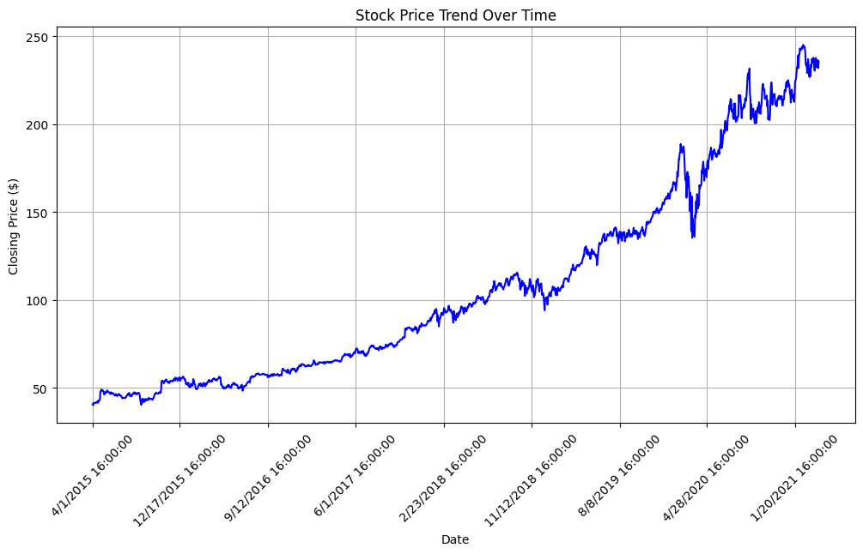

### **3. Network Graph**

A network graph is used to visualize relationships between numerical features based on their correlation.

#### **Code:**

****import networkx as nx

df_numeric = df.select_dtypes(include=[np.number])

corr_matrix = df_numeric.corr()

G = nx.Graph()

threshold = 0.5 # Only show strong correlations

for i in corr_matrix.columns:

for j in corr_matrix.columns:

if i != j and abs(corr_matrix.loc[i, j]) > threshold:

G.add_edge(i, j, weight=corr_matrix.loc[i, j])

plt.figure(figsize=(8, 6))

pos = nx.spring_layout(G)

nx.draw(G, pos, with_labels=True, node_color='skyblue', edge_color='gray', node_size=3000, font_size=10)

# Draw edge labels (correlation values)

edge_labels = {(i, j): f"{corr_matrix.loc[i, j]:.2f}" for i, j in G.edges()}

nx.draw_networkx_edge_labels(G, pos, edge_labels=edge_labels)

plt.title("Feature Correlation Network Graph")

plt.show()

#### **Explanation:**

* The correlation matrix is computed using df.corr().
* A graph is created where nodes represent numerical features.
* Edges (connections) are added if the correlation between two features exceeds a threshold (0.5).
* nx.spring_layout(G) is used to position nodes in a visually appealing way.
* Labels and edge weights (correlation values) are displayed.
* 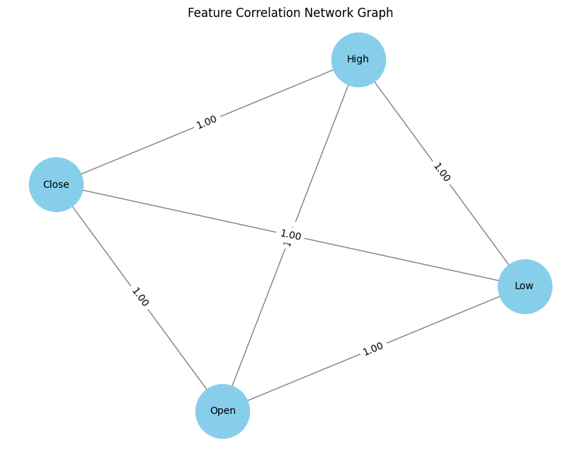

### **4 Distribution of Microsoft Stock Closing Prices**

A histogram is used to visualize the distribution of Microsoft stock's closing prices, helping to understand how often certain price ranges occur.

### **Code:**

python

CopyEdit

* plt.figure(figsize=(8, 6))
* plt.hist(df['Close'], bins=20, color='purple', edgecolor='black')
* plt.title('Distribution of Microsoft Stock Closing Prices')
* plt.xlabel('Closing Price ($)')
* plt.ylabel('Frequency')
* plt.grid(True)
* plt.show()

### **Explanation:**

1. **plt.figure(figsize=(8, 6))**
   * **Purpose:** This initializes the figure with a width of 8 inches and a height of 6 inches.
   * **Explanation:** The figsize argument defines the size of the plot. A smaller size of (8, 6) is chosen to fit a histogram without excessive space around it.
2. **plt.hist(df['Close'], bins=20, color='purple', edgecolor='black')**
   * **Purpose:** This creates the histogram of closing prices.
   * **Explanation:**
     + df['Close']: Refers to the 'Close' column in the DataFrame df, which contains the stock's closing prices.
     + bins=20: Specifies the number of bins (intervals) in the histogram. Here, there are 20 bins, which helps in displaying the distribution of prices across different price ranges.
     + color='purple': Sets the color of the bars in the histogram to purple.
     + edgecolor='black': Adds a black border around each bin for better visibility and separation between bars.

* 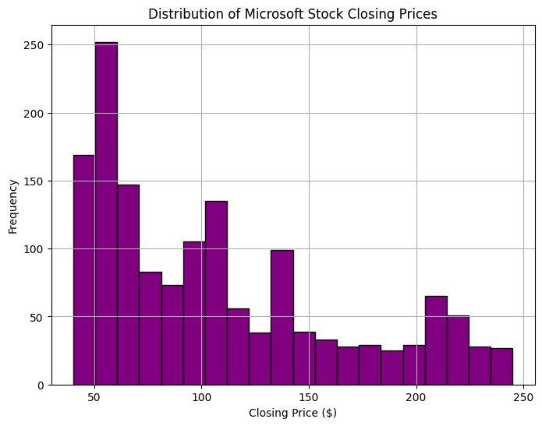

### **5) Box Plot of Microsoft Stock Closing Price**

A box plot is used to visualize the distribution of Microsoft stock's closing prices, highlighting key statistics like the median, quartiles, and outliers.

### **Code:**

python

CopyEdit

plt.figure(figsize=(10, 8))

plt.boxplot(df['Close'], vert=False)

plt.title('Box Plot of Microsoft Stock Closing Price')

plt.xlabel('Closing Price ($)')

plt.show()

### **Explanation:**

1. **plt.figure(figsize=(10, 8))**
   * **Purpose:** Initializes the figure with a specified size.
   * **Explanation:** The figsize argument sets the dimensions of the figure. In this case, the figure has a width of 10 inches and a height of 8 inches, which is suitable for displaying a clear box plot.
2. **plt.boxplot(df['Close'], vert=False)**
   * **Purpose:** Creates the box plot for the 'Close' data.
   * **Explanation:**
     + df['Close']: Refers to the 'Close' column in the DataFrame df, containing the stock's closing prices.
     + plt.boxplot(): This function generates the box plot, which shows the spread and skewness of the closing prices.
     + vert=False: Specifies that the box plot should be horizontal (vert=False). By default, box plots are vertical, but setting it to False changes the orientation for easier reading when dealing with numeric data.

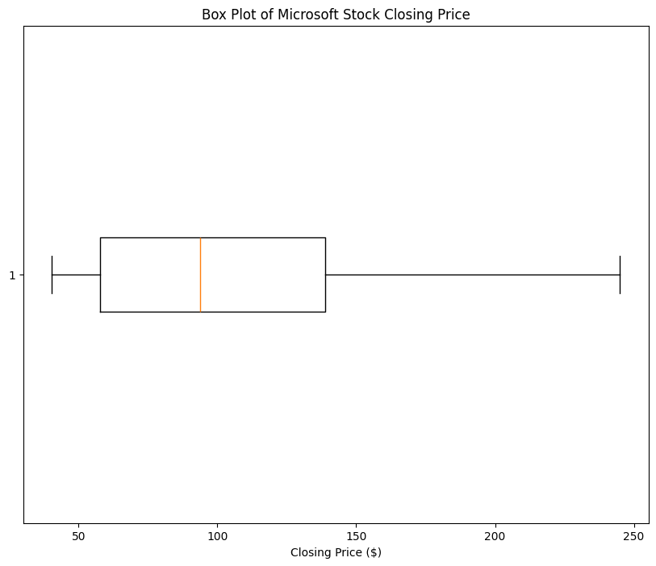

#### **Result:**

Thus the visualization techniques in Time Series Analysis and Forecasting has been studied successfully.